ultramirinc.champs_mood

Class MyViewPager

java.lang.Object

android.view.View

android.view.ViewGroup

android.support.v4.view.ViewPager ultramirinc.champs_mood.MyViewPager

All Implemented Interfaces:

android.graphics.drawable.Drawable.Callback, android.view.accessibility.AccessibilityEventSource, android.view.KeyEvent.Callback, android.view.ViewManager, android.view.ViewParent



public class MyViewPager

extends android.support.v4.view.ViewPager

Created by William on 2017­04­27. This class is a custom ViewPager in order to remove the swiping behavior.

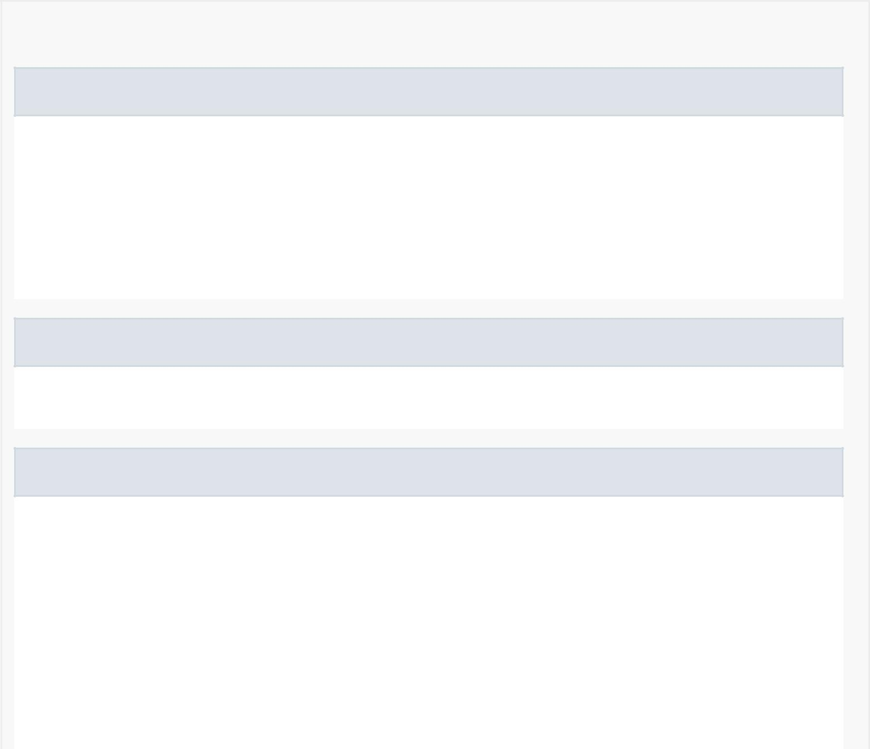

*Nested Class Summary*

Nested classes/interfaces inherited from class android.support.v4.view.ViewPager

android.support.v4.view.ViewPager.DecorView,

android.support.v4.view.ViewPager.LayoutParams,

android.support.v4.view.ViewPager.OnAdapterChangeListener,

android.support.v4.view.ViewPager.OnPageChangeListener,

android.support.v4.view.ViewPager.PageTransformer,

android.support.v4.view.ViewPager.SavedState,

android.support.v4.view.ViewPager.SimpleOnPageChangeListener

Nested classes/interfaces inherited from class android.view.ViewGroup

android.view.ViewGroup.MarginLayoutParams,

android.view.ViewGroup.OnHierarchyChangeListener

Nested classes/interfaces inherited from class android.view.View

android.view.View.AccessibilityDelegate, android.view.View.BaseSavedState, android.view.View.DragShadowBuilder, android.view.View.MeasureSpec, android.view.View.OnApplyWindowInsetsListener, android.view.View.OnAttachStateChangeListener, android.view.View.OnClickListener, android.view.View.OnContextClickListener, android.view.View.OnCreateContextMenuListener, android.view.View.OnDragListener, android.view.View.OnFocusChangeListener, android.view.View.OnGenericMotionListener, android.view.View.OnHoverListener, android.view.View.OnKeyListener, android.view.View.OnLayoutChangeListener, android.view.View.OnLongClickListener, android.view.View.OnScrollChangeListener,

android.view.View.OnSystemUiVisibilityChangeListener,



android.view.View.OnTouchListener

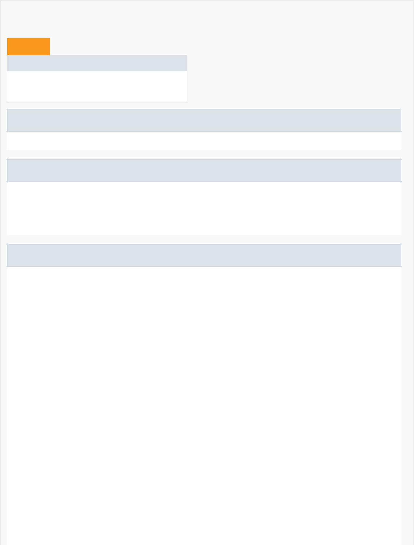

*Field Summary*

Fields

Modifier and Type Field and Description

private boolean enabled

Is the behavior enabled

Fields inherited from class android.support.v4.view.ViewPager

SCROLL_STATE_DRAGGING, SCROLL_STATE_IDLE, SCROLL_STATE_SETTLING

Fields inherited from class android.view.ViewGroup

CLIP_TO_PADDING_MASK, FOCUS_AFTER_DESCENDANTS, FOCUS_BEFORE_DESCENDANTS,

FOCUS_BLOCK_DESCENDANTS, LAYOUT_MODE_CLIP_BOUNDS, LAYOUT_MODE_OPTICAL_BOUNDS,

PERSISTENT_ALL_CACHES, PERSISTENT_ANIMATION_CACHE, PERSISTENT_NO_CACHE,

PERSISTENT_SCROLLING_CACHE

Fields inherited from class android.view.View

ACCESSIBILITY_LIVE_REGION_ASSERTIVE, ACCESSIBILITY_LIVE_REGION_NONE,

ACCESSIBILITY_LIVE_REGION_POLITE, ALPHA, DRAG_FLAG_GLOBAL,

DRAG_FLAG_GLOBAL_PERSISTABLE_URI_PERMISSION,

DRAG_FLAG_GLOBAL_PREFIX_URI_PERMISSION, DRAG_FLAG_GLOBAL_URI_READ,

DRAG_FLAG_GLOBAL_URI_WRITE, DRAG_FLAG_OPAQUE, DRAWING_CACHE_QUALITY_AUTO,

DRAWING_CACHE_QUALITY_HIGH, DRAWING_CACHE_QUALITY_LOW, EMPTY_STATE_SET,

ENABLED_FOCUSED_SELECTED_STATE_SET,

ENABLED_FOCUSED_SELECTED_WINDOW_FOCUSED_STATE_SET, ENABLED_FOCUSED_STATE_SET,

ENABLED_FOCUSED_WINDOW_FOCUSED_STATE_SET, ENABLED_SELECTED_STATE_SET,

ENABLED_SELECTED_WINDOW_FOCUSED_STATE_SET, ENABLED_STATE_SET,

ENABLED_WINDOW_FOCUSED_STATE_SET, FIND_VIEWS_WITH_CONTENT_DESCRIPTION,

FIND_VIEWS_WITH_TEXT, FOCUS_BACKWARD, FOCUS_DOWN, FOCUS_FORWARD, FOCUS_LEFT,

FOCUS_RIGHT, FOCUS_UP, FOCUSABLES_ALL, FOCUSABLES_TOUCH_MODE,

FOCUSED_SELECTED_STATE_SET, FOCUSED_SELECTED_WINDOW_FOCUSED_STATE_SET,

FOCUSED_STATE_SET, FOCUSED_WINDOW_FOCUSED_STATE_SET, GONE, HAPTIC_FEEDBACK_ENABLED,

IMPORTANT_FOR_ACCESSIBILITY_AUTO, IMPORTANT_FOR_ACCESSIBILITY_NO,

IMPORTANT_FOR_ACCESSIBILITY_NO_HIDE_DESCENDANTS, IMPORTANT_FOR_ACCESSIBILITY_YES,

INVISIBLE, KEEP_SCREEN_ON, LAYER_TYPE_HARDWARE, LAYER_TYPE_NONE,

LAYER_TYPE_SOFTWARE, LAYOUT_DIRECTION_INHERIT, LAYOUT_DIRECTION_LOCALE,

LAYOUT_DIRECTION_LTR, LAYOUT_DIRECTION_RTL, MEASURED_HEIGHT_STATE_SHIFT,

MEASURED_SIZE_MASK, MEASURED_STATE_MASK, MEASURED_STATE_TOO_SMALL, NO_ID,

OVER_SCROLL_ALWAYS, OVER_SCROLL_IF_CONTENT_SCROLLS, OVER_SCROLL_NEVER,

PRESSED_ENABLED_FOCUSED_SELECTED_STATE_SET,

PRESSED_ENABLED_FOCUSED_SELECTED_WINDOW_FOCUSED_STATE_SET,



PRESSED_ENABLED_FOCUSED_STATE_SET,

PRESSED_ENABLED_FOCUSED_WINDOW_FOCUSED_STATE_SET,

PRESSED_ENABLED_SELECTED_STATE_SET,

PRESSED_ENABLED_SELECTED_WINDOW_FOCUSED_STATE_SET, PRESSED_ENABLED_STATE_SET,

PRESSED_ENABLED_WINDOW_FOCUSED_STATE_SET, PRESSED_FOCUSED_SELECTED_STATE_SET,

PRESSED_FOCUSED_SELECTED_WINDOW_FOCUSED_STATE_SET, PRESSED_FOCUSED_STATE_SET,

PRESSED_FOCUSED_WINDOW_FOCUSED_STATE_SET, PRESSED_SELECTED_STATE_SET,

PRESSED_SELECTED_WINDOW_FOCUSED_STATE_SET, PRESSED_STATE_SET,

PRESSED_WINDOW_FOCUSED_STATE_SET, ROTATION, ROTATION_X, ROTATION_Y, SCALE_X,

SCALE_Y, SCREEN_STATE_OFF, SCREEN_STATE_ON, SCROLL_AXIS_HORIZONTAL,

SCROLL_AXIS_NONE, SCROLL_AXIS_VERTICAL, SCROLL_INDICATOR_BOTTOM,

SCROLL_INDICATOR_END, SCROLL_INDICATOR_LEFT, SCROLL_INDICATOR_RIGHT,

SCROLL_INDICATOR_START, SCROLL_INDICATOR_TOP, SCROLLBAR_POSITION_DEFAULT,

SCROLLBAR_POSITION_LEFT, SCROLLBAR_POSITION_RIGHT, SCROLLBARS_INSIDE_INSET,

SCROLLBARS_INSIDE_OVERLAY, SCROLLBARS_OUTSIDE_INSET, SCROLLBARS_OUTSIDE_OVERLAY,

SELECTED_STATE_SET, SELECTED_WINDOW_FOCUSED_STATE_SET, SOUND_EFFECTS_ENABLED,

STATUS_BAR_HIDDEN, STATUS_BAR_VISIBLE, SYSTEM_UI_FLAG_FULLSCREEN,

SYSTEM_UI_FLAG_HIDE_NAVIGATION, SYSTEM_UI_FLAG_IMMERSIVE,

SYSTEM_UI_FLAG_IMMERSIVE_STICKY, SYSTEM_UI_FLAG_LAYOUT_FULLSCREEN,

SYSTEM_UI_FLAG_LAYOUT_HIDE_NAVIGATION, SYSTEM_UI_FLAG_LAYOUT_STABLE,

SYSTEM_UI_FLAG_LIGHT_STATUS_BAR, SYSTEM_UI_FLAG_LOW_PROFILE,

SYSTEM_UI_FLAG_VISIBLE, SYSTEM_UI_LAYOUT_FLAGS, TEXT_ALIGNMENT_CENTER,

TEXT_ALIGNMENT_GRAVITY, TEXT_ALIGNMENT_INHERIT, TEXT_ALIGNMENT_TEXT_END,

TEXT_ALIGNMENT_TEXT_START, TEXT_ALIGNMENT_VIEW_END, TEXT_ALIGNMENT_VIEW_START,

TEXT_DIRECTION_ANY_RTL, TEXT_DIRECTION_FIRST_STRONG,

TEXT_DIRECTION_FIRST_STRONG_LTR, TEXT_DIRECTION_FIRST_STRONG_RTL,

TEXT_DIRECTION_INHERIT, TEXT_DIRECTION_LOCALE, TEXT_DIRECTION_LTR,

TEXT_DIRECTION_RTL, TRANSLATION_X, TRANSLATION_Y, TRANSLATION_Z, VIEW_LOG_TAG,

VISIBLE, WINDOW_FOCUSED_STATE_SET, X, Y, Z

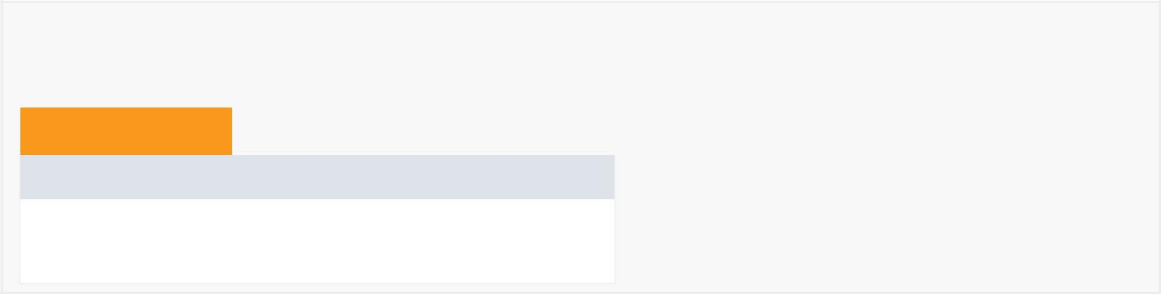

*Constructor Summary*

Constructors

Constructor and Description

MyViewPager(android.content.Context context, android.util.AttributeSet attrs)

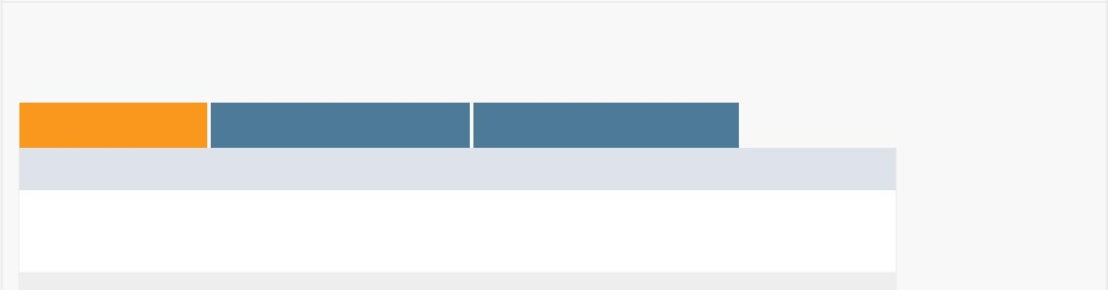

*Method Summary*

All Methods [Instance Methods](javascript:show(2);) [Concrete Methods](javascript:show(8);)

Modifier and Type Method and Description

boolean isPagingEnabled()

Getter for enabled

boolean onInterceptTouchEvent(android.view.MotionEvent event)

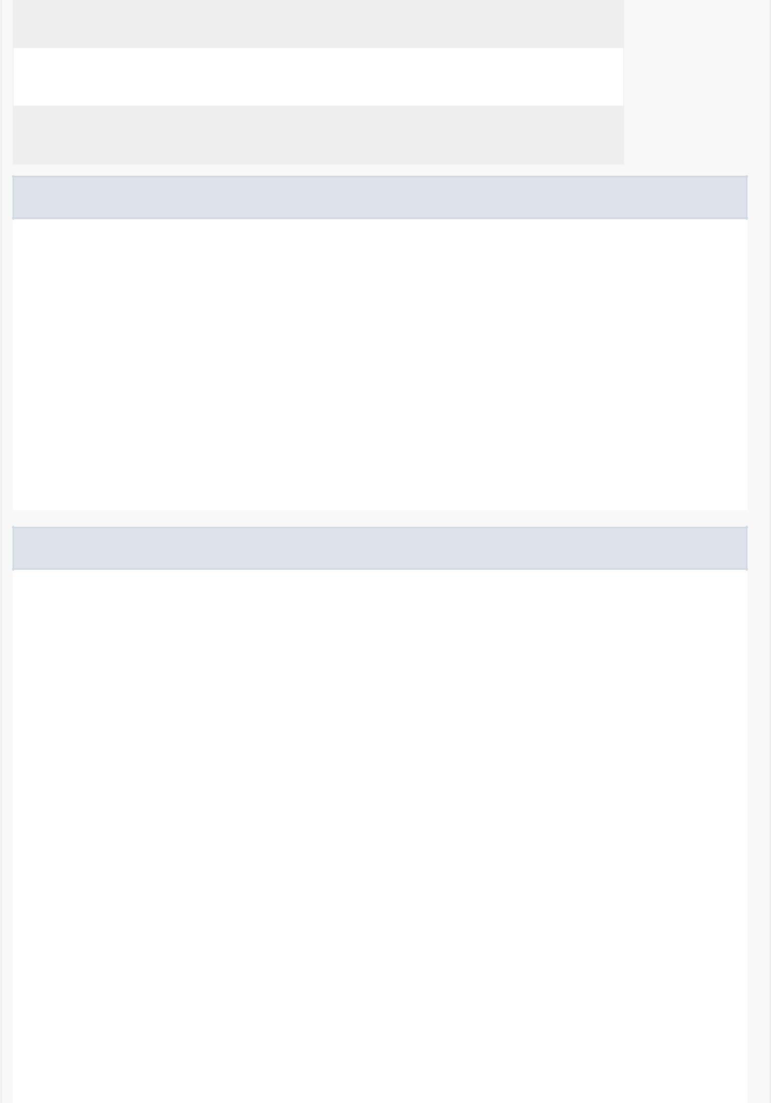

Handles what happens when touch event is intercepted

boolean onTouchEvent(android.view.MotionEvent event)

Handles what happens when the ViewPager is touched

void setPagingEnabled(boolean enabled)

Setter for enabled

Methods inherited from class android.support.v4.view.ViewPager

addFocusables, addOnAdapterChangeListener, addOnPageChangeListener, addTouchables, addView, arrowScroll, beginFakeDrag, canScroll, canScrollHorizontally, checkLayoutParams, clearOnPageChangeListeners, computeScroll, dispatchKeyEvent, dispatchPopulateAccessibilityEvent, draw, drawableStateChanged, endFakeDrag, executeKeyEvent, fakeDragBy, generateDefaultLayoutParams, generateLayoutParams, generateLayoutParams, getAdapter, getChildDrawingOrder, getCurrentItem, getOffscreenPageLimit, getPageMargin, isFakeDragging, onAttachedToWindow, onDetachedFromWindow, onDraw, onLayout, onMeasure, onPageScrolled, onRequestFocusInDescendants, onRestoreInstanceState, onSaveInstanceState, onSizeChanged, removeOnAdapterChangeListener, removeOnPageChangeListener, removeView, setAdapter, setCurrentItem, setCurrentItem, setOffscreenPageLimit, setOnPageChangeListener, setPageMargin, setPageMarginDrawable, setPageMarginDrawable, setPageTransformer, setPageTransformer, verifyDrawable

Methods inherited from class android.view.ViewGroup

addChildrenForAccessibility, addStatesFromChildren, addView, addView, addView, addView, addViewInLayout, addViewInLayout, attachLayoutAnimationParameters, attachViewToParent, bringChildToFront, canAnimate, childDrawableStateChanged, childHasTransientStateChanged, cleanupLayoutState, clearChildFocus, clearDisappearingChildren, clearFocus, debug, detachAllViewsFromParent, detachViewFromParent, detachViewFromParent, detachViewsFromParent, dispatchApplyWindowInsets, dispatchConfigurationChanged, dispatchDisplayHint, dispatchDragEvent, dispatchDraw, dispatchDrawableHotspotChanged, dispatchFreezeSelfOnly, dispatchGenericFocusedEvent, dispatchGenericPointerEvent, dispatchHoverEvent, dispatchKeyEventPreIme, dispatchKeyShortcutEvent, dispatchProvideStructure, dispatchRestoreInstanceState, dispatchSaveInstanceState, dispatchSetActivated, dispatchSetPressed, dispatchSetSelected, dispatchSystemUiVisibilityChanged, dispatchThawSelfOnly, dispatchTouchEvent, dispatchTrackballEvent, dispatchUnhandledMove, dispatchVisibilityChanged, dispatchWindowFocusChanged, dispatchWindowSystemUiVisiblityChanged, dispatchWindowVisibilityChanged, drawChild, endViewTransition, findFocus, findViewsWithText, focusableViewAvailable, focusSearch, gatherTransparentRegion, getAccessibilityClassName, getChildAt, getChildCount, getChildMeasureSpec, getChildStaticTransformation, getChildVisibleRect, getClipChildren, getClipToPadding, getDescendantFocusability, getFocusedChild, getLayoutAnimation, getLayoutAnimationListener, getLayoutMode, getLayoutTransition, getNestedScrollAxes, getOverlay, getPersistentDrawingCache, getTouchscreenBlocksFocus, hasFocus, hasFocusable, hasTransientState, indexOfChild, invalidateChild, invalidateChildInParent, isAlwaysDrawnWithCacheEnabled,

isAnimationCacheEnabled, isChildrenDrawingOrderEnabled, isChildrenDrawnWithCacheEnabled, isMotionEventSplittingEnabled, isTransitionGroup, jumpDrawablesToCurrentState, layout, measureChild, measureChildren, measureChildWithMargins, notifySubtreeAccessibilityStateChanged, offsetDescendantRectToMyCoords, offsetRectIntoDescendantCoords, onCreateDrawableState, onInterceptHoverEvent, onNestedFling, onNestedPreFling, onNestedPrePerformAccessibilityAction, onNestedPreScroll, onNestedScroll, onNestedScrollAccepted, onRequestSendAccessibilityEvent, onResolvePointerIcon, onStartNestedScroll, onStopNestedScroll, onViewAdded, onViewRemoved, recomputeViewAttributes, removeAllViews, removeAllViewsInLayout, removeDetachedView, removeViewAt, removeViewInLayout, removeViews, removeViewsInLayout, requestChildFocus, requestChildRectangleOnScreen, requestDisallowInterceptTouchEvent, requestFocus, requestSendAccessibilityEvent, requestTransparentRegion, scheduleLayoutAnimation, setAddStatesFromChildren, setAlwaysDrawnWithCacheEnabled, setAnimationCacheEnabled, setChildrenDrawingCacheEnabled, setChildrenDrawingOrderEnabled, setChildrenDrawnWithCacheEnabled, setClipChildren, setClipToPadding, setDescendantFocusability, setLayoutAnimation, setLayoutAnimationListener, setLayoutMode, setLayoutTransition, setMotionEventSplittingEnabled, setOnHierarchyChangeListener, setPersistentDrawingCache, setStaticTransformationsEnabled, setTouchscreenBlocksFocus, setTransitionGroup, shouldDelayChildPressedState, showContextMenuForChild, showContextMenuForChild, startActionModeForChild, startActionModeForChild, startLayoutAnimation, startViewTransition, updateViewLayout

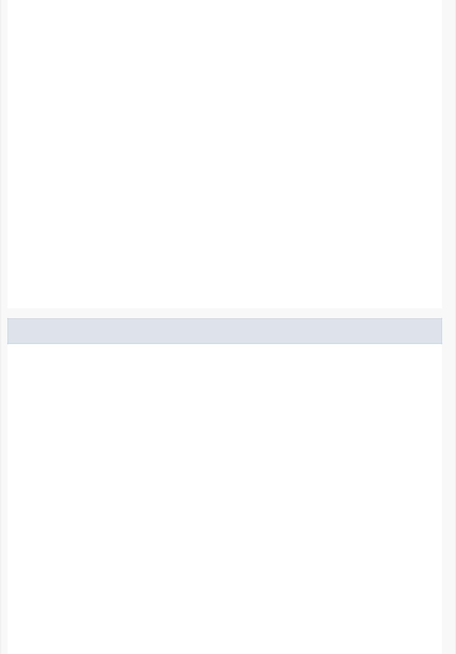

Methods inherited from class android.view.View

addFocusables, addOnAttachStateChangeListener, addOnLayoutChangeListener, animate, announceForAccessibility, awakenScrollBars, awakenScrollBars, awakenScrollBars, bringToFront, buildDrawingCache, buildDrawingCache, buildLayer, callOnClick, cancelDragAndDrop, cancelLongPress, cancelPendingInputEvents, canResolveLayoutDirection, canResolveTextAlignment, canResolveTextDirection, canScrollVertically, checkInputConnectionProxy, clearAnimation, combineMeasuredStates, computeHorizontalScrollExtent, computeHorizontalScrollOffset, computeHorizontalScrollRange, computeSystemWindowInsets, computeVerticalScrollExtent, computeVerticalScrollOffset, computeVerticalScrollRange, createAccessibilityNodeInfo, createContextMenu, destroyDrawingCache, dispatchFinishTemporaryDetach, dispatchGenericMotionEvent, dispatchNestedFling, dispatchNestedPreFling, dispatchNestedPrePerformAccessibilityAction, dispatchNestedPreScroll, dispatchNestedScroll, dispatchStartTemporaryDetach, drawableHotspotChanged, findViewById, findViewWithTag, fitSystemWindows, focusSearch, forceHasOverlappingRendering, forceLayout, generateViewId, getAccessibilityLiveRegion, getAccessibilityNodeProvider, getAccessibilityTraversalAfter, getAccessibilityTraversalBefore, getAlpha, getAnimation, getApplicationWindowToken, getBackground, getBackgroundTintList, getBackgroundTintMode, getBaseline, getBottom, getBottomFadingEdgeStrength, getBottomPaddingOffset, getCameraDistance, getClipBounds, getClipBounds, getClipToOutline, getContentDescription, getContext, getContextMenuInfo, getDefaultSize, getDisplay, getDrawableState, getDrawingCache, getDrawingCache, getDrawingCacheBackgroundColor, getDrawingCacheQuality, getDrawingRect,

getDrawingTime, getElevation, getFilterTouchesWhenObscured, getFitsSystemWindows, getFocusables, getFocusedRect, getForeground, getForegroundGravity, getForegroundTintList, getForegroundTintMode, getGlobalVisibleRect, getGlobalVisibleRect, getHandler, getHasOverlappingRendering, getHeight, getHitRect, getHorizontalFadingEdgeLength, getHorizontalScrollbarHeight, getId, getImportantForAccessibility, getKeepScreenOn, getKeyDispatcherState, getLabelFor, getLayerType, getLayoutDirection, getLayoutParams, getLeft, getLeftFadingEdgeStrength, getLeftPaddingOffset, getLocalVisibleRect, getLocationInWindow, getLocationOnScreen, getMatrix, getMeasuredHeight, getMeasuredHeightAndState, getMeasuredState, getMeasuredWidth, getMeasuredWidthAndState, getMinimumHeight, getMinimumWidth, getNextFocusDownId, getNextFocusForwardId, getNextFocusLeftId, getNextFocusRightId, getNextFocusUpId, getOnFocusChangeListener, getOutlineProvider, getOverScrollMode, getPaddingBottom, getPaddingEnd, getPaddingLeft, getPaddingRight, getPaddingStart, getPaddingTop, getParent, getParentForAccessibility, getPivotX, getPivotY, getPointerIcon, getResources, getRevealOnFocusHint, getRight, getRightFadingEdgeStrength, getRightPaddingOffset, getRootView, getRootWindowInsets, getRotation, getRotationX, getRotationY, getScaleX, getScaleY, getScrollBarDefaultDelayBeforeFade, getScrollBarFadeDuration, getScrollBarSize, getScrollBarStyle, getScrollIndicators, getScrollX, getScrollY, getSolidColor, getStateListAnimator, getSuggestedMinimumHeight, getSuggestedMinimumWidth, getSystemUiVisibility, getTag, getTag, getTextAlignment, getTextDirection, getTop, getTopFadingEdgeStrength, getTopPaddingOffset, getTouchables, getTouchDelegate, getTransitionName, getTranslationX, getTranslationY, getTranslationZ, getVerticalFadingEdgeLength, getVerticalScrollbarPosition, getVerticalScrollbarWidth, getViewTreeObserver, getVisibility, getWidth, getWindowAttachCount, getWindowId, getWindowSystemUiVisibility, getWindowToken, getWindowVisibility, getWindowVisibleDisplayFrame, getX, getY, getZ, hasNestedScrollingParent, hasOnClickListeners, hasOverlappingRendering, hasWindowFocus, inflate, invalidate, invalidate, invalidate, invalidateDrawable, invalidateOutline, isAccessibilityFocused, isActivated, isAttachedToWindow, isClickable, isContextClickable, isDirty, isDrawingCacheEnabled, isDuplicateParentStateEnabled, isEnabled, isFocusable, isFocusableInTouchMode, isFocused, isHapticFeedbackEnabled, isHardwareAccelerated, isHorizontalFadingEdgeEnabled, isHorizontalScrollBarEnabled, isHovered, isImportantForAccessibility, isInEditMode, isInLayout, isInTouchMode, isLaidOut, isLayoutDirectionResolved, isLayoutRequested, isLongClickable, isNestedScrollingEnabled, isOpaque, isPaddingOffsetRequired, isPaddingRelative, isPressed, isSaveEnabled, isSaveFromParentEnabled, isScrollbarFadingEnabled, isScrollContainer, isSelected, isShown, isSoundEffectsEnabled, isTemporarilyDetached, isTextAlignmentResolved, isTextDirectionResolved, isVerticalFadingEdgeEnabled, isVerticalScrollBarEnabled, measure, mergeDrawableStates, offsetLeftAndRight, offsetTopAndBottom, onAnimationEnd, onAnimationStart, onApplyWindowInsets, onCancelPendingInputEvents, onCheckIsTextEditor, onConfigurationChanged, onCreateContextMenu, onCreateInputConnection, onDisplayHint, onDragEvent, onDrawForeground, onDrawScrollBars, onFilterTouchEventForSecurity, onFinishInflate, onFinishTemporaryDetach, onFocusChanged, onGenericMotionEvent, onHoverChanged, onHoverEvent, onInitializeAccessibilityEvent, onInitializeAccessibilityNodeInfo, onKeyDown, onKeyLongPress, onKeyMultiple, onKeyPreIme, onKeyShortcut, onKeyUp, onOverScrolled, onPopulateAccessibilityEvent, onProvideStructure, onProvideVirtualStructure, onRtlPropertiesChanged, onScreenStateChanged,



onScrollChanged, onSetAlpha, onStartTemporaryDetach, onTrackballEvent, onVisibilityAggregated, onVisibilityChanged, onWindowFocusChanged, onWindowSystemUiVisibilityChanged, onWindowVisibilityChanged, overScrollBy, performAccessibilityAction, performClick, performContextClick, performContextClick, performHapticFeedback, performHapticFeedback, performLongClick, performLongClick, playSoundEffect, post, postDelayed, postInvalidate, postInvalidate, postInvalidateDelayed, postInvalidateDelayed, postInvalidateOnAnimation, postInvalidateOnAnimation, postOnAnimation, postOnAnimationDelayed, refreshDrawableState, removeCallbacks, removeOnAttachStateChangeListener, removeOnLayoutChangeListener, requestApplyInsets, requestFitSystemWindows, requestFocus, requestFocus, requestFocusFromTouch, requestLayout, requestRectangleOnScreen, requestRectangleOnScreen, requestUnbufferedDispatch, resolveSize, resolveSizeAndState, restoreHierarchyState, saveHierarchyState, scheduleDrawable, scrollBy, scrollTo, sendAccessibilityEvent, sendAccessibilityEventUnchecked, setAccessibilityDelegate, setAccessibilityLiveRegion, setAccessibilityTraversalAfter, setAccessibilityTraversalBefore, setActivated, setAlpha, setAnimation, setBackground, setBackgroundColor, setBackgroundDrawable, setBackgroundResource, setBackgroundTintList, setBackgroundTintMode, setBottom, setCameraDistance, setClickable, setClipBounds, setClipToOutline, setContentDescription, setContextClickable, setDrawingCacheBackgroundColor, setDrawingCacheEnabled, setDrawingCacheQuality, setDuplicateParentStateEnabled, setElevation, setEnabled, setFadingEdgeLength, setFilterTouchesWhenObscured, setFitsSystemWindows, setFocusable, setFocusableInTouchMode, setForeground, setForegroundGravity, setForegroundTintList, setForegroundTintMode, setHapticFeedbackEnabled, setHasTransientState, setHorizontalFadingEdgeEnabled, setHorizontalScrollBarEnabled, setHovered, setId, setImportantForAccessibility, setKeepScreenOn, setLabelFor, setLayerPaint, setLayerType, setLayoutDirection, setLayoutParams, setLeft, setLongClickable, setMeasuredDimension, setMinimumHeight, setMinimumWidth, setNestedScrollingEnabled, setNextFocusDownId, setNextFocusForwardId, setNextFocusLeftId, setNextFocusRightId, setNextFocusUpId, setOnApplyWindowInsetsListener, setOnClickListener, setOnContextClickListener, setOnCreateContextMenuListener, setOnDragListener, setOnFocusChangeListener, setOnGenericMotionListener, setOnHoverListener, setOnKeyListener, setOnLongClickListener, setOnScrollChangeListener, setOnSystemUiVisibilityChangeListener, setOnTouchListener, setOutlineProvider, setOverScrollMode, setPadding, setPaddingRelative, setPivotX, setPivotY, setPointerIcon, setPressed, setRevealOnFocusHint, setRight, setRotation, setRotationX, setRotationY, setSaveEnabled, setSaveFromParentEnabled, setScaleX, setScaleY, setScrollBarDefaultDelayBeforeFade, setScrollBarFadeDuration, setScrollbarFadingEnabled, setScrollBarSize, setScrollBarStyle, setScrollContainer, setScrollIndicators, setScrollIndicators, setScrollX, setScrollY, setSelected, setSoundEffectsEnabled, setStateListAnimator, setSystemUiVisibility, setTag, setTag, setTextAlignment, setTextDirection, setTop, setTouchDelegate, setTransitionName, setTranslationX, setTranslationY, setTranslationZ, setVerticalFadingEdgeEnabled, setVerticalScrollBarEnabled, setVerticalScrollbarPosition, setVisibility, setWillNotCacheDrawing, setWillNotDraw, setX, setY, setZ, showContextMenu, showContextMenu, startActionMode, startActionMode, startAnimation, startDrag, startDragAndDrop, startNestedScroll, stopNestedScroll, toString, unscheduleDrawable, unscheduleDrawable, updateDragShadow, willNotCacheDrawing, willNotDraw



Methods inherited from class java.lang.Object

clone, equals, finalize, getClass, hashCode, notify, notifyAll, wait, wait, wait

Methods inherited from interface android.view.ViewParent

canResolveLayoutDirection, canResolveTextAlignment, canResolveTextDirection, createContextMenu, getLayoutDirection, getParent, getParentForAccessibility, getTextAlignment, getTextDirection, isLayoutDirectionResolved, isLayoutRequested, isTextAlignmentResolved, isTextDirectionResolved, requestFitSystemWindows, requestLayout

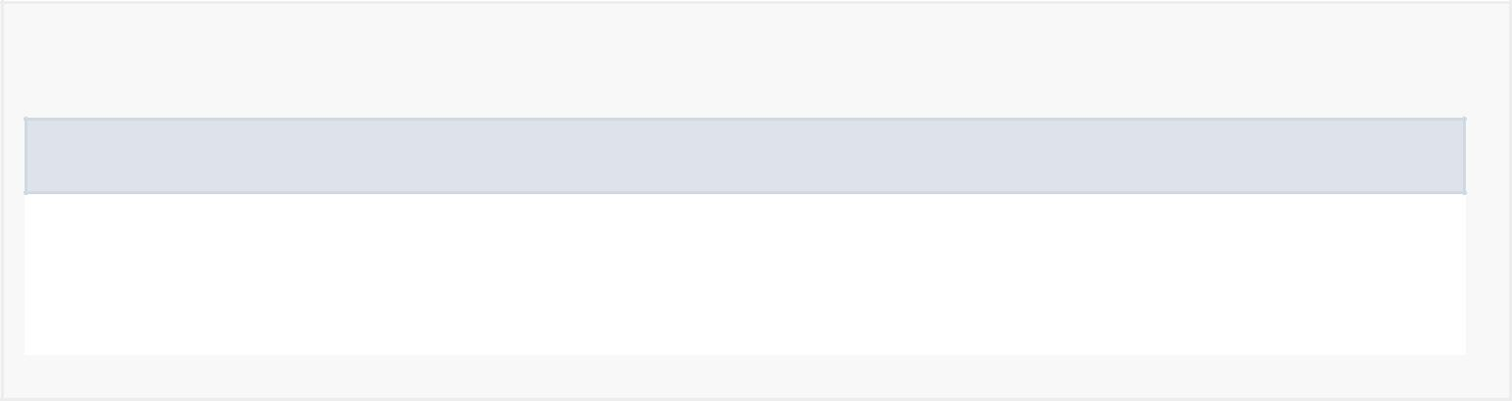

*Field Detail*

enabled

private boolean enabled

Is the behavior enabled

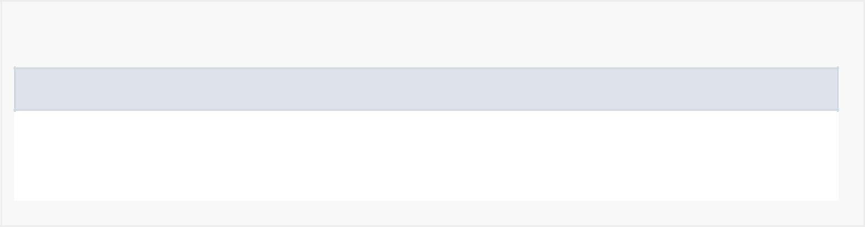

*Constructor Detail*

MyViewPager

public MyViewPager(android.content.Context context, android.util.AttributeSet attrs)

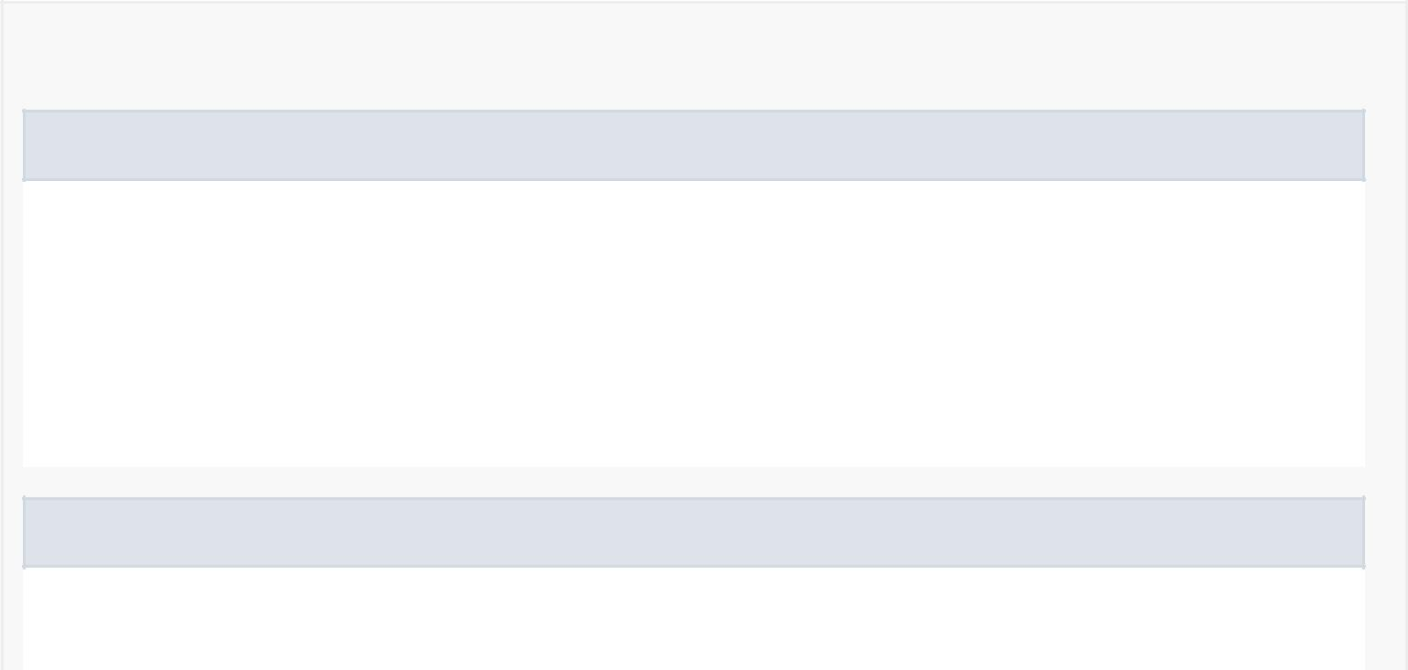

*Method Detail*

onTouchEvent

public boolean onTouchEvent(android.view.MotionEvent event)

Handles what happens when the ViewPager is touched

Overrides:

onTouchEvent in class android.support.v4.view.ViewPager

onInterceptTouchEvent

public boolean onInterceptTouchEvent(android.view.MotionEvent event)

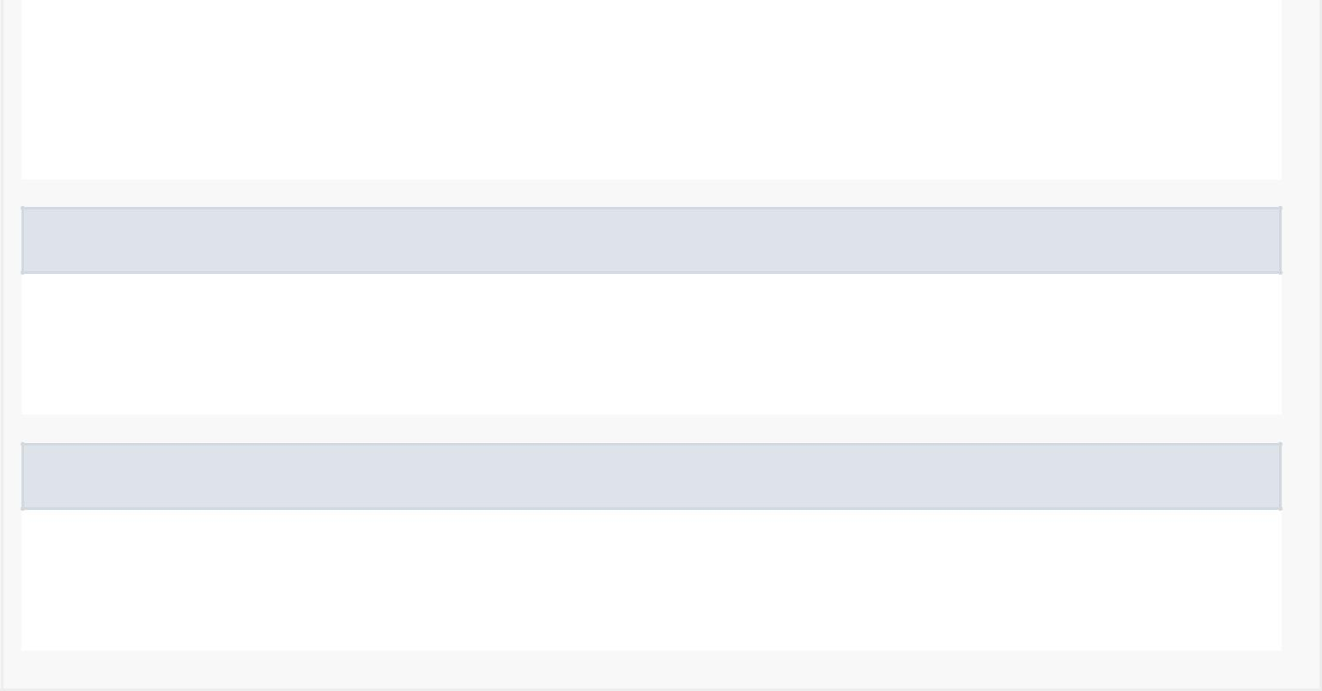Handles what happens when touch event is intercepted

Overrides:

onInterceptTouchEvent in class android.support.v4.view.ViewPager

setPagingEnabled

public void setPagingEnabled(boolean enabled)

Setter for enabled

isPagingEnabled

public boolean isPagingEnabled()

Getter for enabled